Integration Test

Application

Prerequireties
- Check out the latest code from the Git SCM.
- Install ofono-phonesim

Test Procedure
Start ofono-phonesim via
ofono-phonesim -p 12345 -gui ~/OpenEmbedded/ofono-phonesim/default.xml
Start the application.

Klick on PHONE
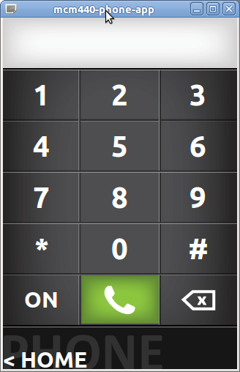
Click on 'ON' to turn the modem on

Bitbake Image

